**Chain Reaction (With UI)**

**Project by:**

Vishal K

Grade XI

June 2021

**Project Details:**

**Programming Language:** Python (Pygame Module)

**Code editor:** Visual Studio Code

**Project Statement:** **'Chain Reaction'** is an exciting turn-based multiplayer strategy game that challenges players to strategically place their orbs in the cells of a grid consisting of cells arranged both horizontally and vertically. The goal of the game is to eliminate all the cells of your opponents and be the last player standing on the grid. The cells are explosive and can trigger a chain reaction, causing the neighboring cells to explode as well, thereby leading to a strategic and exciting gameplay experience.

The game was inspired by a popular mobile game of the same name developed by **App Holdings**, which is available on **Google Play Stores**. 'Chain Reaction' offers multiple game modes and allows players to customize the color of their cells and the background of the game. With its engaging gameplay and multiplayer capabilities, 'Chain Reaction' is a game that promises loads of fun and entertainment for all players.

**Check out the actual game using the given link:**

<https://play.google.com/store/apps/details?id=com.BuddyMattEnt.ChainReaction>

**Game Rules and Description:**

The objective of Chain Reaction is to take control of the board by eliminating your opponents' **Orbs**.

Players take it in turns to place their orbs in a cell. Once a cell has reached \***critical mass** the orbs explode into the surrounding cells adding an extra orb and claiming the cell for the player. A player may only place their orbs in a blank cell or a cell that contains orbs of their own colour. As soon as a player looses all their orbs they are out of the game.

**\*critical mass:**

* 2 for corner cells
* 3 for edge cells
* 4 for center cells

**Gameplay Images:**

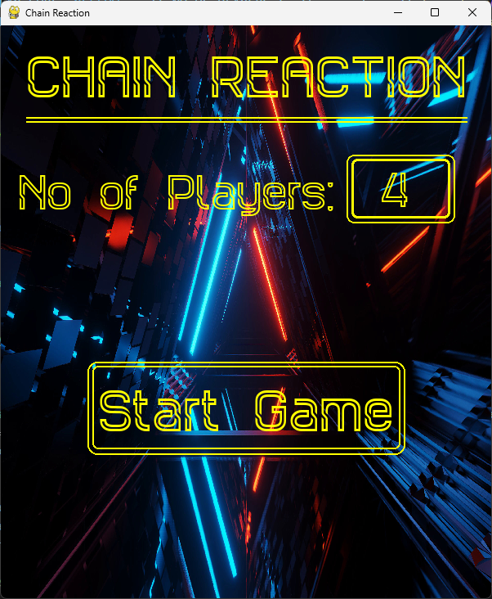

**Beginning of the game**

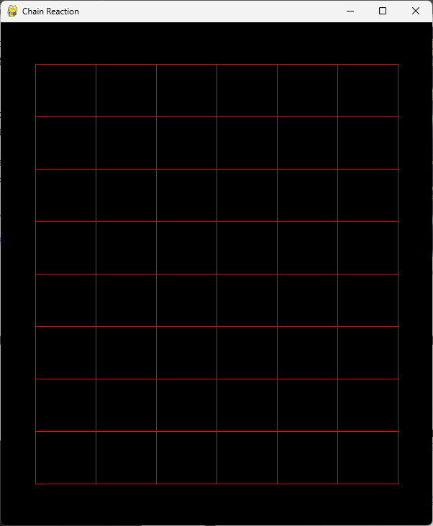

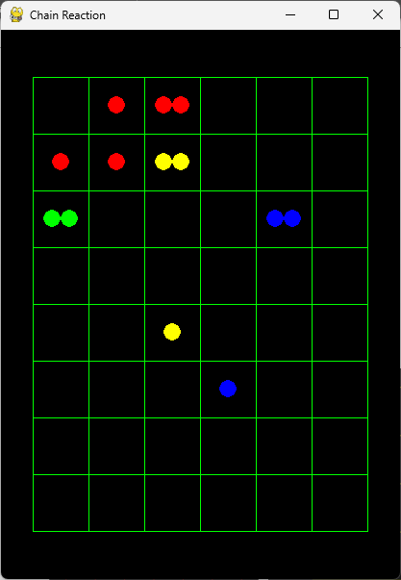 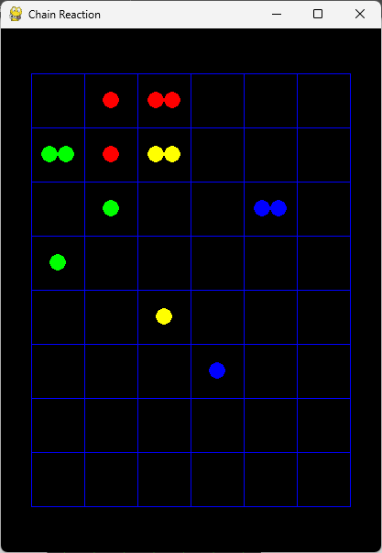

**Cell 20 before explosion** **Cell 20 After Explosion**

**References:**

**Chain Reaction Original Game by App Holdings:** <https://play.google.com/store/apps/details?id=com.BuddyMattEnt.ChainReaction>

**My GitHub Repository:**

[https://github.com/IAmACodeGeek/Chain-Reaction-](https://github.com/IAmACodeGeek/Chain-Reaction-Console-Based-Python)Python-Pygame